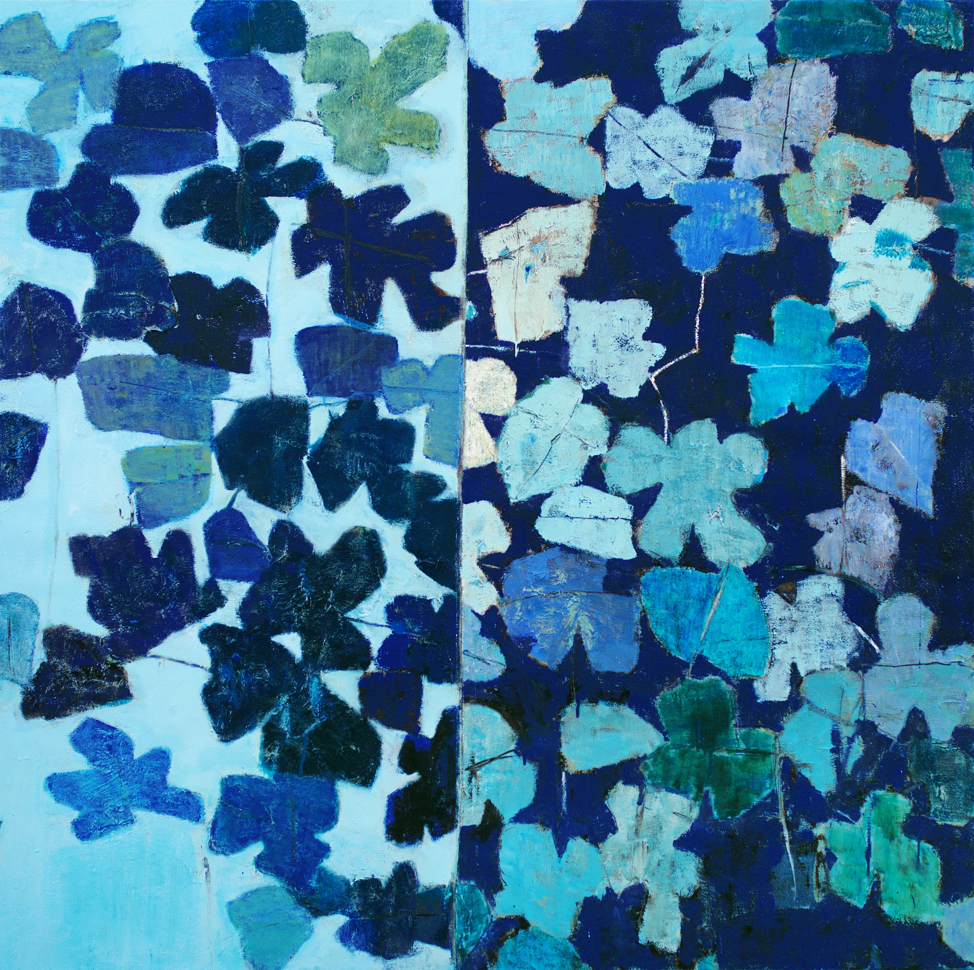

REZA DERAKSHANI

The Shadow of a Fig Tree
Quiets My Soul

FIGS

scent of a fig tree thick in summer air,
shadows of her beautiful hands, like shiva,
kneading the darkness, dancing.
drops of sweet white juice on the way back from school in the summer heat
the desert shining like a silver sky
through the long night,
this longing for you ripens and thickens we dive toward insanity
you pluck my chords,
and the song echoes across the universe. each day, each night.
the night you made a promise: the day of reunion.
I count up the days, every day and every night.
thirst near to my eyes, drops of sweet white juice, the shadow of a fig tree quiets my soul.

-Reza Derakshan

PRESS RELEASE

Leila Heller is pleased to announce The Shadow of a Fig Tree Quiets My Soul, an exhibition of work by Persian- American artist Reza Derakshani on view February 25, 2020 through April 18th, 2020. Marking his third solo show at Leila Heller in New York, Derakshani's exhibition is comprised of eight large paintings. His work celebrates both ornamentation and color fields, as the artist finds a space for figural representation in abstract aesthetics.
In the Day and Night and Fig Tree series, Derakshani explores opposing themes of the world. While aesthetically ornamented, the paintings express a duality of experiences and reflect the fullness and ambiguity of life. In the Garden Party series, Derakshani interprets traditional metaphors for heaven and the afterlife, where families communally gather and feast under tents in vivid and idyllic gardens.
Inserting subjectivity through expressive brushstrokes, while gracefully interweaving strong colors, textures, and luxurious metal paints, Derakshani’s paintings often mimic poetry and music. For the artist, painting is a spiritual process that allows for a return to physicality and beauty, in a rejection of the irony that often permeates contemporary painting.

ABOUT THE ARTIST

Born in 1952 in Sangsar, a small village in the North East of Iran, Reza Derakshani is a painter, poet, musician and performance artist. Derakshani studied at Pasadena School of Art, going on to teach at the University of Tehran before leaving the country in 1986 to Italy and subsequently to New York.
Reza Derakshani’s work is featured in many public art collections including the British Museum, London; the Metropolitan Museum of Art, New York; the State Russian Museum; the Museum Gunzenhauser, Germany; the Tehran Museum of Contemporary Art and numerous private collections including those of the Sheikha Salama Bint Hamdan Al Nahyan Foundation, Abu Dhabi; SPM, Salsali private museum, Dubai; Leon and Debra Black collection, New York; the Farjam Foundation, Dubai; Trudie Styler & Sting collection, London and Italy; the Freymond Foundation, New York; the Royal family of Morocco; and the Eisler Foundation, among others. Derakshani also performed as a musician at the Brooklyn Museum of New York, the Montreux Jazz Festival, and the Dubai Stadium in the UAE, among others.
He now spends his time between his studios in St Petersburg, Russia and Austin, Texas.

ABOUT THE GALLERY

Since its establishment over three decades ago in New York, Leila Heller Gallery has gained worldwide recognition as a pioneer in promoting a creative dialogue and exchange between Western artists and Middle Eastern, Central and Southeast Asian artists. It has garnered a reputation for identifying and cultivating the careers of artists leaving a lasting impact on contemporary art and culture. Currently representing a diverse roster of Western and Middle Eastern artists, the gallery is also active in the American, European and Middle Eastern secondary art markets. In November 2015, Leila Heller Gallery opened its first international location in Dubai’s Alserkal Avenue. At 14,000 square feet, the state-of-the-art gallery features three exhibition spaces, making it the largest gallery in the UAE. Showcasing leading regional and international artists, many of whom will be presenting their work in the Middle East for the first time, the gallery is dedicated to supporting the evolving practice of established artists.

Press Inquiries: For more information, images and prices, please contact ella@leilaheller.com

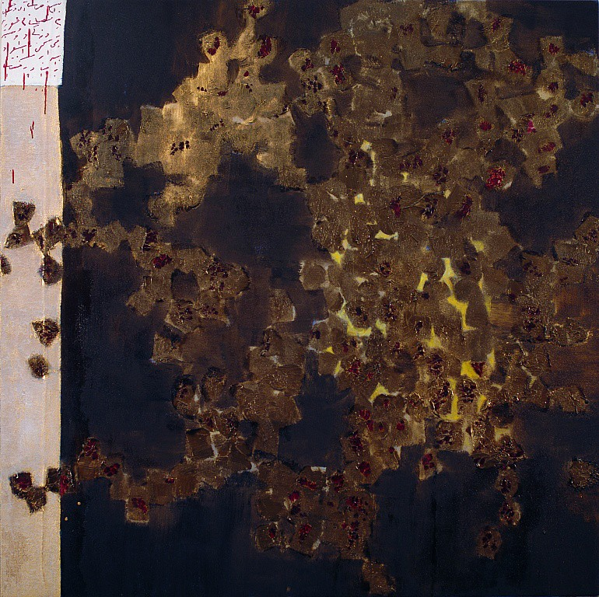

Reza Derakshani
They Drink Secretly, 2018
Oil and Gold Paste on Canvas
70.08 x 70.08 in, 178 x 178 cm
$ 80,000.00

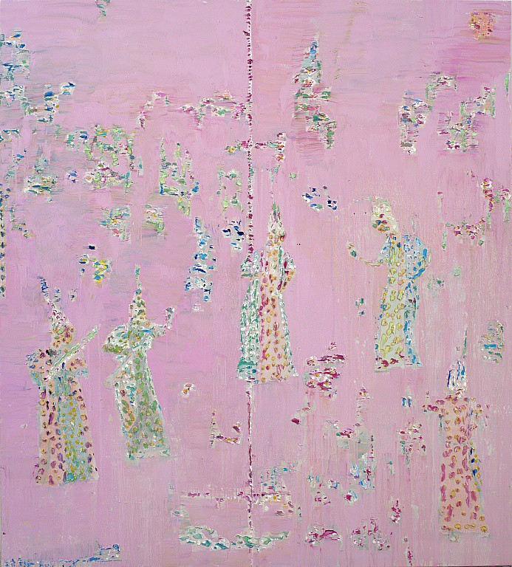

Reza Derakshani
Pink Party, 2020
Oil on Canvas
70.87 x 66.92 in, 180 x 170 cm
$ 85,000.00

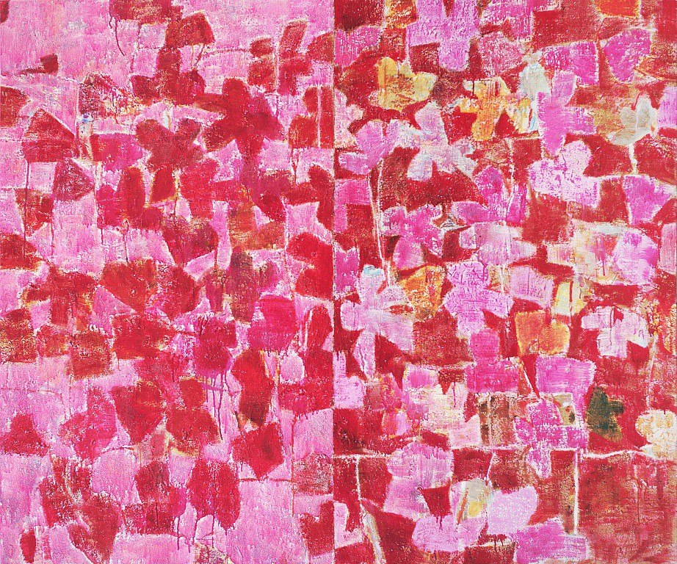

Reza Derakshani
Pink Days and Nites, 2016
Oil on Canvas
60.24 x 72.05 in, 153 x 183 cm
$ 65,000.00

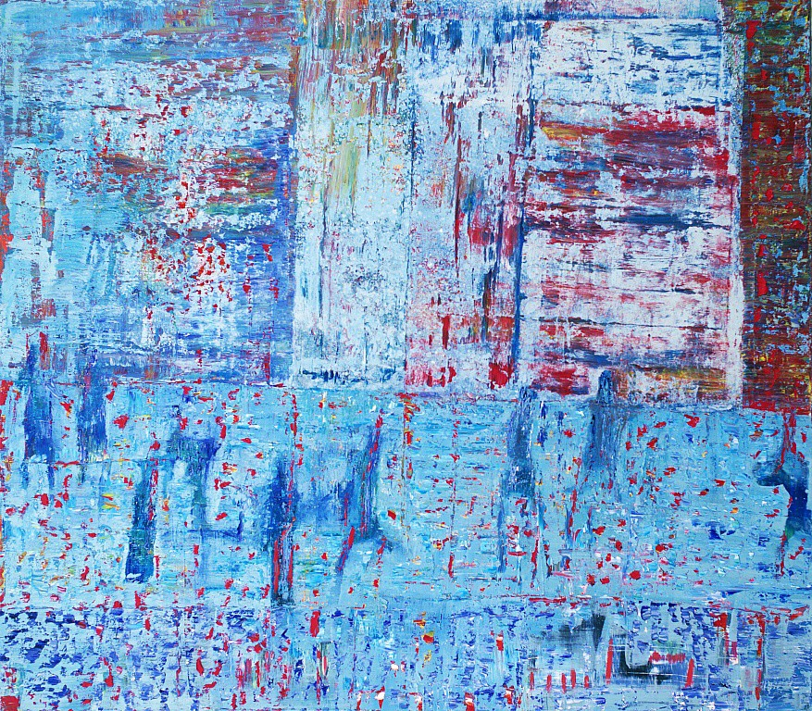

Reza Derakshani
Morning Party, 2020
Oil on Canvas
70.08 x 79.92 in, 178 x 203 cm
$ 90,000.00

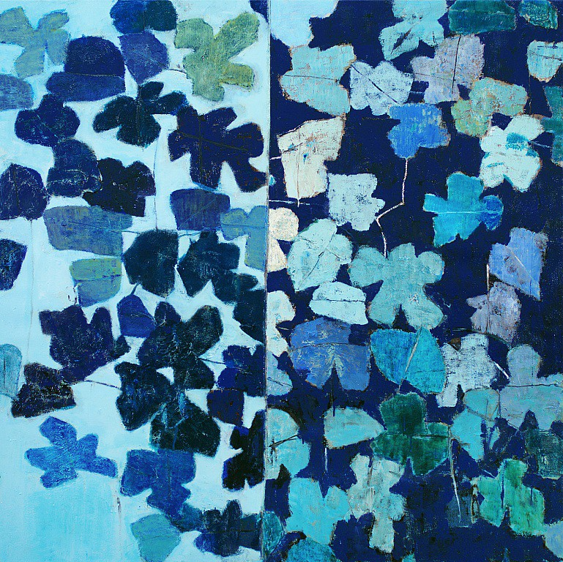

Reza Derakshani
Every Blue Day Night, 2010
Oil and Tar on Canvas
70.08h x 70.08w in 178h x 178w cm
$ 70,000.00

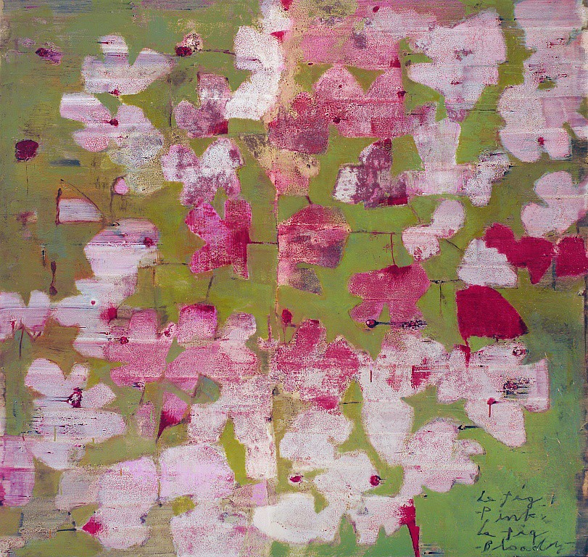

Reza Derakshani
Le Fig Pink Le Fig Green, 2016
Oil and Tar on Canvas
66.14 x 70.08 in, 168 x 178 cm
$ 70,000.00

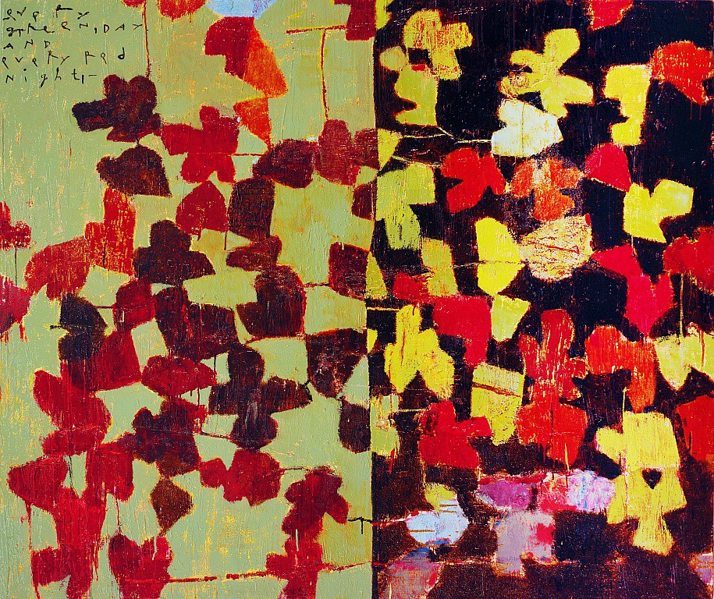

Reza Derakshani
Every Green Day and Every Red Night, 2010
Oil and Tar on Canvas
59.84 x 72.05 in, 152 x 183 cm
$ 65,000.00

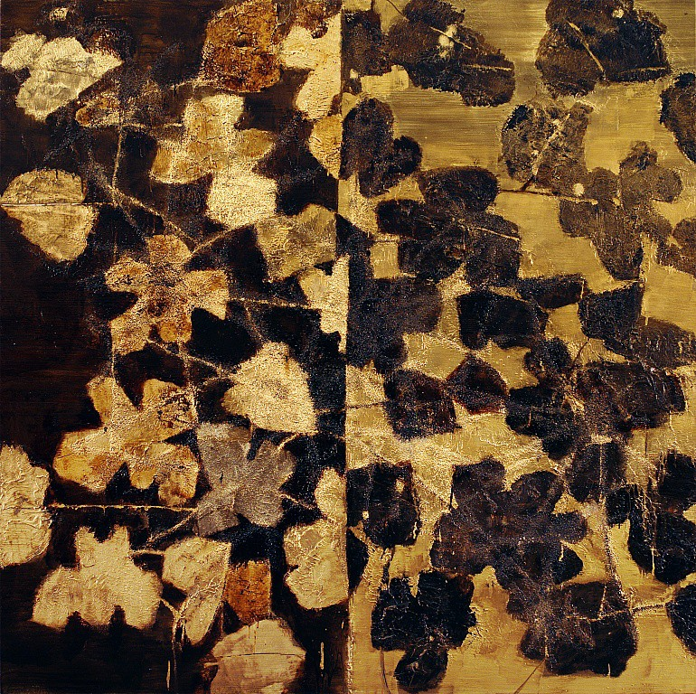

Reza Derakshani
Every Gold Day and the Dark Night, 2018
Oil and Tar on Canvas
70.08 x 70.08 in, 178 x 178 cm
$ 80,000.00

