BILL VIOLA
The Vast: Mirrors of the Mind

March 14 – April 22, 2017

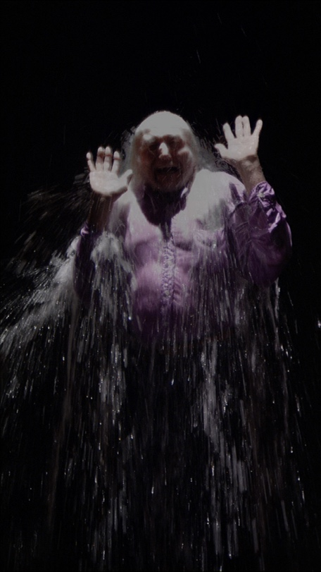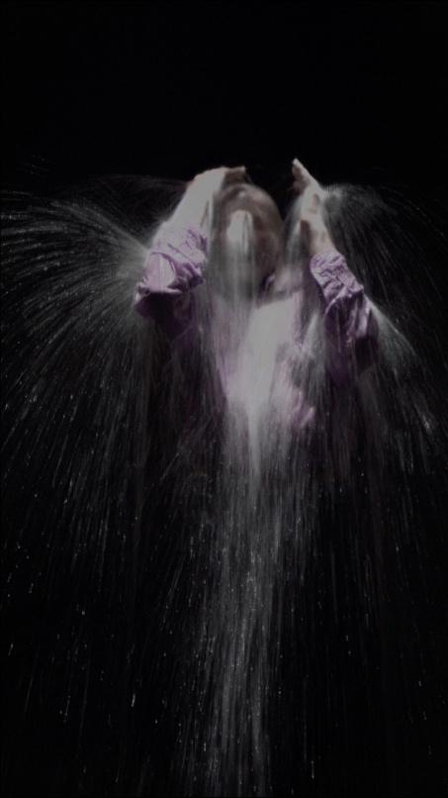
Howard, 2008, Color high-definition video on flat panel display, 55.1 x 35.5 x 5.7 cm, Edition of 3 + 2 Aps. Photo: Kira Perov

In every atom are a hundred blazing suns
If you cleave the heart of one drop of water
A hundred pure emotions emerge from it
Mahmud Shabistari (13th century) quoted in Viola’s Reasons for Knocking at an Empty House

Leila Heller Gallery Dubai is proud to present an exhibition of the work of Bill Viola, entitled The Vast: Mirrors of the Mind, curated by Brooke Lynn McGowan. Presenting a selection of pioneering video pieces, including works from the Sufi-inspired Transfigurations series (created 2007–2008), desert-based mediations on existence from the Mirage series (2012), and the hauntingly infinite fluidity of the Water Portraits series (2013), The Vast: Mirrors of the Mind seeks to reveal to the viewer the thematic relationships in Viola’s work—portrayals of desert and water as emblematic of his explorations of the voyage of life and death, consciousness and reflection, East to West. Each of the works in this exhibition portray Viola’s representation of the limits of perception at the threshold between the conscious and the unconscious mind and his desire to “go to a place that seems like it’s at the end of the world. A vantage point from which one can stand and peer out into the void… where all becomes strange and unfamiliar…. You have reached the edge… You finally realize that the void is yourself. It is like … [a] mirror in your mind.”

The desert, for Viola, is the mirror of the mind. The vast, harsh, arid landscape is the first point of contact that the artist discovered, between the physical and the psychological, producing mirages, which Viola terms as early as 1979 as “hallucinations of landscape”—the experience, he notes, “of being in someone else’s dream.” Using the medium of video to explore the layers of reality and illusion in the physical world of the desert expanse, the Mirage series, including Lifespans (2012) and Walking on the Edge (2012), seeks to investigate the limits of our understanding of the position of the human in the natural order, both physically and metaphysically. The artist describes, Walking on the Edge, noting

This work represents the inevitable separation of father and son as they take separate paths in their life’s journey. Two men arrive in the desert under a turbulent sky. They appear at the far extremes of the frame and walk toward us on a trajectory that takes them closer to each other, until they are walking side by side. Eventually they cross paths and begin to separate. The gap between them widens until they leave the outer edges of the frame.

For Viola, this “inner as well as outer journey” presents the viewer with the desert landscape as the landscape of the mind, in what has been called one of his ‘purest’ statements on the voyage through consciousness towards our perception of the exterior world. Here, the edge he seeks has been reached. The desert is the void. And thus also is the self.

If the desert appears as a leitmotif throughout Viola’s oeuvre, so does water, conceived by the artist both as analogous to the very medium of video, as well as possessing symbolic connotations of the passage of birth, death, and renewal. No examples of this are at once more compelling and more haunting than the pieces from the Transfigurations series and Water Portraits series. The former were created in concert with the artist’s installation for the 52nd Venice Biennale, Ocean Without a Shore, which took its title from the writings of the 13th century Andalusian Sufi mystic Ibn ’Arabi, who wrote, “The self is an ocean without a shore. Gazing upon it has no beginning or end, in this world and the next”.

Like the couples on a perpetual journey in the desert, Lenny (2008) and Howard (2008), two Transfigurations series, each portray figures on a voyage that is interminable because it is eternal. The artist explains, these “series of encounters at the intersection between life and death” occur as the figure appears at first grainy and in black and white, reaching through an invisible until breached wall of water, signifying a birth, emerging in full colour before the viewer. However, as the subjects realizes that their existence in the incarnate world is finite, they, according to Viola, “eventually turn away from material existence to return from where they came. The cycle repeats without end.” Here, the water signifies both life and death, an endless voyage of renewal. These works, like others from his oeuvre, express the importance to the artist of Sufism as a form of philosophic and aesthetic grounding for his work. In 1976, taking from this Islamic tradition of transcendental metaphysics, Viola writes, “One of the foundations of the ancient philosophy [of Sufism] is the concept of the correspondence between microcosm and macrocosm, or the belief that everything on the higher order, or scale, of existence reflects… the manifestation…of lower orders.” Every level of existence mirrors.

The endlessness of the journeys of the Mirage and Transfigurations series meets an uncanny stillness in the haunting images of the Water Portrait series, three of which are presented in this exhibition. Accompanied by the sound of gently flowing water, the three videos, Sharon (2013), Blake’s Dream (2013), and Madison (2013), each portray a woman, a young man, and a little girl respectively completely submerged beneath the water, still, eyes closed, moved only by the gentle rippling of the current. Writing in notebooks in 1980, Viola notes, “Death is non-movement/Stillness is life/Stillness is death/Stillness is the root of all life.” Thus, despite the melancholic and certainly meditative presentation of these dreamers, whose countenance recalls as much as it subverts the 19th century use of photographs as mementos to the dead, the works portray the liminal state of sleep, between the conscious and the unconscious, where stillness, and the water which surrounds, is life, is death, is the root of all life.

This exhibition has been made possible through close collaboration with Bill Viola Studio and Blain|Southern.

About Bill Viola (b 1951, USA):
For over forty years, Viola’s practice has continuously transformed our understanding of video as an art form, expanding its technological scope and historical relevance. He draws from a range of influences, including Eastern and Western art and the spiritual traditions of Zen Buddhism, Islamic Sufism and Christian mysticism, to express fundamental truths underpinning human existence. Bill Viola’s profound visual language captures and reveals thoughts, feelings and memories that have a universal appeal, offering viewers a vehicle for the exploration and contemplation of their own circumstances and emotions. Since the early 1970s Viola’s video art works have been seen all over the world. Viola has held solo exhibitions at the Museum of Modern Art, New York; U.S. Pavilion exhibition at the 46th Venice Biennale; the Whitney Museum, New York; J. Paul Getty Museum, Los Angeles; National Gallery, London; Fondación ‘La Caixa’, Madrid; National Gallery of Australia, Canberra; Grand Palais, Paris; National Portrait Gallery, Washington D.C.; and Guggenheim Museum, Bilbao, Spain.
Receiving his BFA in Experimental Studios from Syracuse University in 1973, Viola holds honorary doctorates from Syracuse University (1995), The School of the Art Institute of Chicago (1997), California Institute of the Arts (2000), and Royal College of Art, London (2004) among others. He is the recipient of numerous awards and honors including a John D. and Catherine T. MacArthur Foundation Fellowship in 1989. He was inducted into the American Academy of Arts and Sciences in 2000 and in 2006 he was awarded Commander of the Order of Arts and Letters by the French Government. In 2009 he received the XXI Catalonia International Prize in Barcelona, Spain. Viola was awarded the Praemium Imperiale art award in the category of painting in 2011. Viola was made a National Academician of the New York based National Academy in June 2012.
Bill Viola and Kira Perov, his wife and long-time collaborator, live and work in Long Beach, California.

About the Gallery:
Since its establishment over three decades ago in New York, Leila Heller Gallery has gained worldwide recognition as a pioneer in promoting creative dialogue and exchange between Western artists and Middle Eastern, Central and Southeast Asian artists. It has garnered a reputation for identifying and cultivating the careers of artists leaving a lasting impact on contemporary art and culture. Currently representing a diverse roster of Western and Middle Eastern artists, the gallery is also active in the American, European and Middle Eastern secondary art markets. In November 2015, Leila Heller Gallery opened its first international location in Dubai’s Alserkal Avenue. At 14,000 square feet, the state of the art gallery features three exhibition spaces, making it the largest gallery in the UAE. Showcasing leading regional and international artists, many of whom will be presenting their work in the Middle East for the first time, the gallery is dedicated to supporting the evolving practice of established artists.

Press Inquiries: For more information and images, please contact Jolaine Frizzell, Leila Heller Gallery, jolaine@leilahellergallery.com

